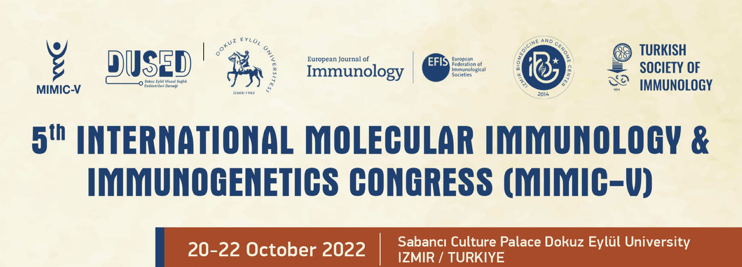

MIMIC-V TSI/EFIS/EJI GRANTS

THE ORGANIZING COMMITTEE IS PROUD TO ANNOUNCE THAT THERE ARE PLENY OF OPPORTUNITIES TO RECEIVE TSI-EFIS-EJI SUPPORT DURING MIMIC-V CONGRESS

• TSI/EFIS/EJI REGISTRATION, TRAVEL AND ACCOMODATION GRANTS WILL BE AVAILABLE TO THOSE PARTICIPANTS WHO WILL BE SELECTED FOR ORAL PRESENTATIONS (MAX. 20 SLOTS).

• APPLICANTS WITH POSTER ABSTRACTS WILL RECEIVE REGISTRATION WAIVER GRANTS (MAX. 100 SLOTS).

• SELECTED POSTER PRESENTERS WILL RECEIVE TRAVEL AND ACCOMODATION GRANTS. (MAX. 40 SLOTS)

PLEASE MAKE SURE YOU SUBMIT YOUR ABSTRACTS BEFORE 1ST OF OCTOBER. THE APPLICANTS WHO SUBMIT THEIR WORKS AFTER 1ST OF OCTOBER WILL NOT BE ELIGIBLE FOR TSI/EFIS/EJI GRANTS.

Grant Application Form

Abstract Ref. Number :

Name :
Surname :
E-mail :
Mobile Phone Number :
İnstitution :
City / Country :

For grant application,
please fill that form and send it to istanbul2@devent.com.tr by e-mail until 7 October.

